**Assignment 6**

// Assignment - 1

// Salary Slip of Employee

// Input :

// Id - 1001

// name- amit srivastava - output : Amit Srivastava

// basic salary - 10000

// HRA - House Rent Allowance - 50% of Basic Salary

// DA - Dearness Allowance - 15% of BS

// TA - Travelling Allowance - 20% of BS

// MA - Medical Allowance - 20% of MA

// PF - 5% of the BS (Employee) + 5% Employer

// GS - BS + HRA + DA + TA + MA

// TAX - >5L (Annual Salary) 10% Tax

// >7L 20% Tax

// >9L 30% Tax

// Print Salary Slip

// Amount - Rs Symbol 50,000

// Hint:

// Date : Current Date

// Local class

// Follow : SRP, DRY , Pascal Case, camelCase, Encapsulation ,Data Hiding

class Employee{

private int  id;

private  String name;

private int basicSalary;

private double amount;

public void takeEmployeeInput(int id,String name,int basicSalary){

    this.id=id;

    this.name=name;

    this.basicSalary=basicSalary;

}

public void allAllowance(){

    double HRA=0.5*basicSalary;

    double TA=0.3*basicSalary;

    double MA=0.25*basicSalary;

    double PF=0.1*basicSalary;

    double GrossSalary=basicSalary+HRA+TA+MA;

}

public int annualSalaryCalculator(){

    return 12*basicSalary;

}

public void taxCalculator(){

    int annualSalary=annualSalaryCalculator();

    if(annualSalary>500000)

    amount=(annualSalary*90)/100;

    else if(annualSalary>700000)

    amount=(annualSalary*80)/100;

    else if(annualSalary>900000)

    amount=(annualSalary*70)/100;

}

public void printSalary(){

   System.out.println("Name-: "+name);

   System.out.println("ID-: "+id);

   System.out.println("Amount-:"+amount);

}

}

public class SalaryEmployee {

    public static void main(String[] args) {

        Employee emp1=new Employee();

        emp1.takeEmployeeInput(111,"Harry Styles", 40000);

        emp1.printSalary();

    }

}

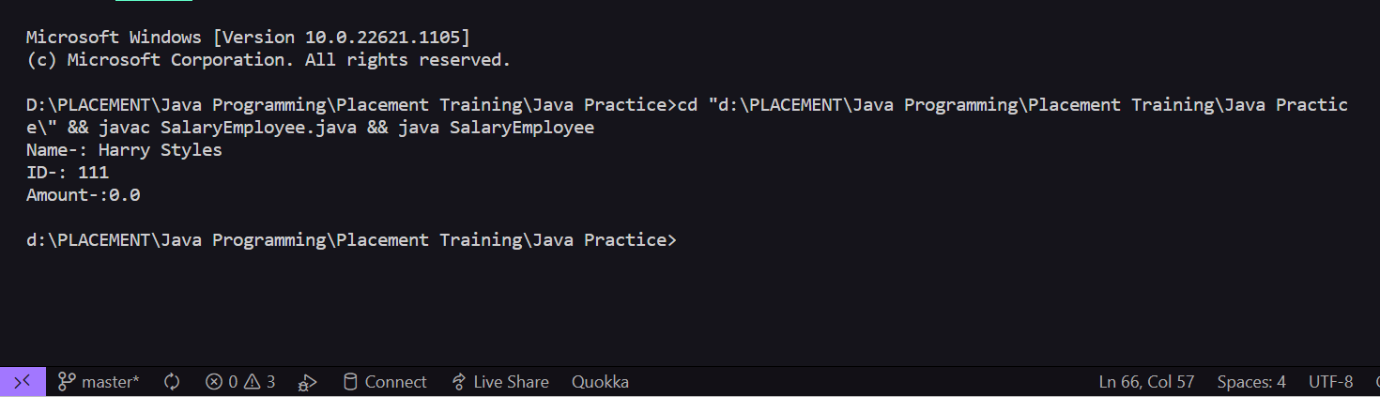

// Assignment -2

// Print Student Report Card

// RollNo - 1001

// Take Name - Amit Srivastava

// Take 3 Subject Marks

// 90

// 100

// 88

// Compute Total Marks

// Compute Percentage

// Print Grade

// >90 A Grade

// <90 to >=70 B Grade

// <70 to>=60 C Grade

// <60 to>=50 D Grade

// <50 F Grade

class Student{

    private int rollNumber;

    private String name;

    private int subject1;

    private int subject2;

    private int subject3;

    private char grade;

    public void takeInput(int rollNumber,String name,int subject1, int subject2,int subject3){

        this.name=name;

        this.rollNumber=rollNumber;

        this.subject1=subject1;

        this.subject2=subject2;

        this.subject3=subject3;

    }

    public double Percentage(){

        double percent=((subject1+subject2+subject3)*100)/300;

        return percent;

    }

    public void getGrade(){

        if(Percentage()>90)

        grade='A';

        else if(Percentage()<90 && Percentage()>=70)

        grade='B';

        else if(Percentage()<70 && Percentage()>=60)

        grade='C';

        else if(Percentage()<60 && Percentage()>=50)

        grade='D';

        else

        grade='F';

    }

    public void printReport(){

        System.out.println("Name of Student--"+name);

        System.out.println("Roll Number--"+rollNumber);

        System.out.println("Subject One--"+subject1);

        System.out.println("Subject Two--"+subject1);

        System.out.println("Subject Three--"+subject1);

        System.out.println("Percentage--"+Percentage());

        System.out.println("Grade--"+grade);

    }

}

public class ReportCard {

    public static void main(String[] args) {

        Student s1=new Student();

        s1.takeInput(1, "Harry Lewis", 88, 98, 90);

        s1.getGrade();

        s1.printReport();

    }

}

